|  |  |
| --- | --- |
| USE CASE SPECIFICATION | |
| Use Case Name | Indicate Attendance |
| Brief Description | This use case enables the user to mark their attendance for an event that they are keen to attend. The user must be successfully logged into the CMP before indicating their attendance for an event. |
| Actors | |
| Primary Actor/s | Start-up Founder, Alumni |
| Secondary Actor/s | Admin |
| Flow of Events | |
| Main Flow (MF) | |
|  | SUCCESSFUL REGISTER INTO PORTAL  The use case begins with the system displaying a confirmation message to the user on the screen. |
|  | SIGNUP EVENT (ACCEPT EVENT)  The user will log-in to the portal to view event lists. The user will select an event that interest them and view the event detail. The user then clicks the sign-up button to register for the event. |
|  | EVENT EMAIL INVITATION  The admin will send an event invitation to the user’s email. |
|  | JOIN MEETING  The user will click on the ‘Join meeting’ link attached in the invitation email to join the meeting. |
|  | INDICATE ATTENDANCE  The system will mark the attendance of the user. The attendance will be indicated in the list of attendees which can be view by the admin. The use case ends. |
| Alternate Flows (AF) | |
|  | FAIL TO JOIN MEETING  At MF 4.1.4, the user fails to click on the link in the invitation. The user would not be able to join the meeting, their attendance will not be indicated, and the use case ends. |
|  | ERROR INDICATING ATTENDANCE  At MF 4.1.5, the system failed to mark the attendance of the user after clicking on the ‘join meeting’ link, the attendance will not be indicated in the list of attendees. The use case ends. |

***STEP 1: Extract Nouns from use case specification***

|  |  |  |  |
| --- | --- | --- | --- |
| Nouns | Reject/Accept | reason to Reject | Type of class |
| System | Accept |  | Control (system name is ‘CMP’) |
| Screen | Accept |  | Interface |
| Attendance | Accept |  | Entity |
| User | Reject | Out of scope |  |
| Admin | Reject | Synonym of User |  |
| Attendees | Reject | Synonym of User |  |
| Link | Reject | Unclear and in need of focus |  |
| Meeting | Reject | Unclear and in need of focus |  |
| Confirmation Message | Reject | Action of screen |  |
| Invitation | Reject | Out of Scope |  |
| Email | Reject | Out of scope |  |

***Step 2: Draw Basic Class Diagram***

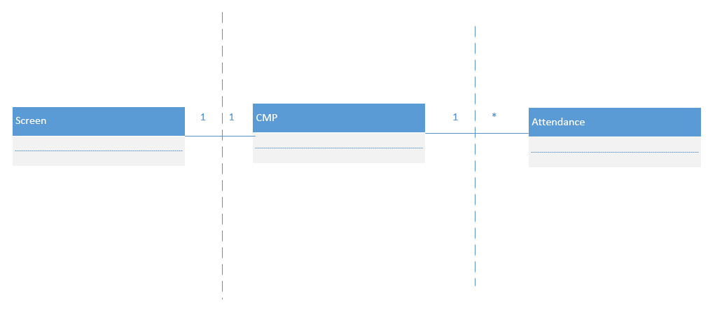

***Step 3: Draw partial detailed class diagram (add attributes to the basic class diagram)***

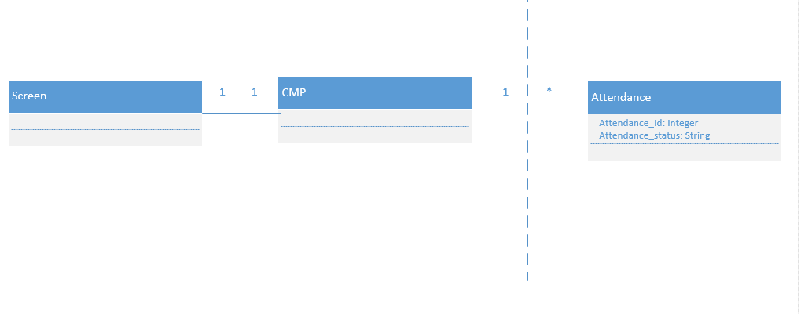

***Step 4: Verb Table (verbs can be extracted from MF of the use case specification)***

|  |  |  |
| --- | --- | --- |
| **Verbs** | **Initiator** | **Recipient** |
| Displays (a confirmation message) | Screen | Screen |
| Select (an event) | User | Screen |
| click (sign-up button) | Screen | CMP |
| Send (event invitation) | CMP | Attendance |
| Click (meeting link) | User | Screen |
| mark (the attendance) | Screen | CMP |
| Indicate (attendance) | CMP | Attendance |

**Step 5: draw the sequence diagram**

